Schedule 2017- 2018 Dynamic Edge Dance Center
September 2017-June 2018 400 Biltmore Dr Suite 410 Fenton, MO 63026 PHONE (636) 305-9898
Revised 7/10/2017 EMAIL: contact@dynamicedgedancecenter.com WEBSITE: www.dynamicedgedancecenter.com
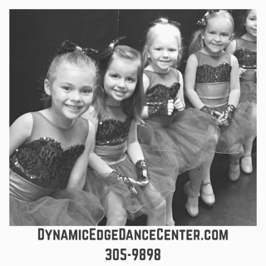
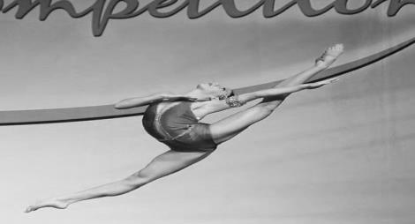
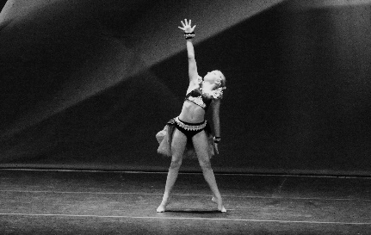

Studio 5
Monday:
9:00-10:00 Work Out With Mommy
10:00-10:30 Pre Dazzler Ballet
10:30-10:45 Mini Tumble Add On
10:45-11:30 Mini Dazzler
11:30-12:30 Mommy & Me
1:30-2:30 Homeschool Dance Class
5:30-6:00 Pre Dazzler Ballet
6:00-6:15 Mini Tumble Add On
6:15-7:00 Mini Dazzler
7:45-8:30 Vocals

Tuesday:
5:00-6:00 Yoga
6:00-6:15 Mini Tumble Add On
6:15-7:00 Mini Dazzler
7:00-8:00 Musical Theater

Wednesday:
5:30-6:00 Pre Dazzler Tap
6:00-6:15 Mini Tumble Add On
6:15-7:00 Mini Dazzler

Thursday:
9:00-10:00 Work Out With Mommy
10:00-10:30 Pre Dazzler Ballet
10:30-10:45 Mini Tumble Add On
10:45-11:30 Mini Dazzler
11:30-12:30 Mommy & Me
1:30-2:30 Homeschool Dance Class
5:30-6:00 Song & Dance
6:00-6:15 Mini Tumble Add On
6:15-7:00 Mini Dazzler

Saturday:
9:00-9:15 Mini Tumble Add On
9:15-10:00 Mini Dazzler
Studio 6
Monday:
4:45-5:30 Mommy & Me
6:00-7:00 Dazzler
7:00-8:00 Poms
8:00-8:45 Adult Tap/Jazz

Tuesday:
5:00-6:00 Contemporary 1
6:00-7:00 Dazzler
7:00-8:00 Cheerleading
8:00-9:00 Acting

Wednesday:
4:15-4:45 Tap 1
4:45-5:15 Jazz 1
5:15-6:00 D-Team Rehearsal 1
6:00-7:00 Dazzler
7:00-8:00 Just Jazz
8:00-9:00 Teen Tap/Jazz

Thursday:
5:00-5:30 Improv Class
5:30-6:00 Partnering
6:00-7:00 Jazz Funk
7:00-8:00 Acro 1 & 2
8:00-9:00 Adult Barre/Ballet

Saturday:
9:00-10:00 Dance Exercise Class
10:00-11:00 Dazzler
11:00-12:00 Dynamic Dazzler
Monthly Tuition:
30 Min Class $38.00 45 Min Class $45.00
60 Min Class $48.00 90 Min Class $65.00
Mommy & Me $55.00 Mini Tumble Add On $5.00
*Discounts for multiple classes and homeschool class
*Sibling Discounts
*ask a staff member for discount pricing

Studio 7
Monday:
5:00-6:00 Hip Hop 1
6:00-7:00 Dynamic Dazzler
7:00-8:00 Contemporary 2
8:00-9:00 School Dance Team Prep

Tuesday:
4:30-5:00 Tricks/Flex
5:00-6:00 Conditioning
6:00-7:00 Dynamic Dazzler
7:00-8:00 Dance Concepts
8:00-9:00 Dance Exercise Class

Wednesday:
5:30-6:30 Hip Hop 2
6:45-7:30 Pointe 1
7:30-8:15 Pre Teen/ Teen Ballet

Thursday:
4:00-5:00 Jumps & Turns
5:00-6:00 Pre Teen Tap/Jazz
6:00-7:00 Dazzler
7:00-8:00 Musical Theater

Saturday:
9:15-10:00 Ballet 1
10:00-11:00 Acro 2
11:00-12:00 Acro 1
Want more DANCE?
Add a class- check our schedule to find back to back classes!
Consider joining our Competitive D-Team- ask a staff member for more details!
Book your next birthday party here with us! Ask for more details at the front desk.
Book a Girl Scout or playgroup event with us! Ask for more details at the front desk.

Studio 8
Monday:
4:15-5:15 FUNdamentals
5:15-6:00 Tap 3
6:00-7:00 Hip Hop 3
7:00-7:45 Tap 4
7:45-8:30 Contemporary 3
8:30-9:30 Jazz 4

Tuesday:
4:00-5:00 Jumps & Turns
5:00-6:00 Acro 4
6:00-7:00 Acro 3
7:00-8:00 Sports Acro/D-Team Sports Acro
8:00-9:00 Ballet 2-4
9:00-9:45 Pointe 2

Wednesday:
4:15-5:15 Jazz 3
5:15-6:45 Ballet 3
6:45-7:30 Ballet 2
7:30-9:00 Ballet 4
9:00-9:30 Combos

Thursday:
4:15-5:00 Tap 2
5:00-6:00 Jazz 2
6:00-6:30 Stretch & Flex
6:30-8:00 Ballet 3
8:00-9:30 Ballet 4

Saturday:
9:00 D-Team Rehearsal 2

Recital:
Recital is in June 2018-exact date TBA
Costumes will be ordered starting in November.
Fun way to showcase all their hard work!

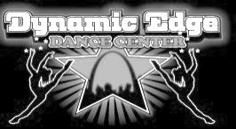
Dynamic Edge Dance Center
400 Biltmore Dr.
Suite 410 Fenton, MO 63026 PHONE (636) 305-9898
EMAIL: contact@dynamicedgedancecenter.com WEBSITE: www.dynamicedgedancecenter.com

Dynamic Edge Dance Center Staff:

Lisa Sabath- Owner/Artistic Director
Sarah Penberthy- Assistant Artistic Director
Joanne Spiro- Office Manager

Instructors:
Cameron Ballard
Brigitte Bartola- Swain
Sarah Beck
Samantha Knight
Jessica Kohut
Michael Littlefield
Andrea Manfrede
Dee Meadows
Erin Ruggeri
Dani Smelser
Amy Stumpf

*Please note that teachers are subject to change at any time throughout the season. Substitute or guest teachers may be brought in to fill in for Miss Lisa or Miss Sarah at any time, especially at recital and competition times.
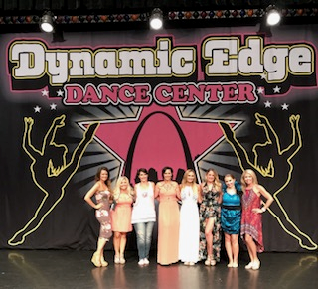

Monthly Tuitions & Private Lessons:
30 minute class $38.00
45 minute class $45.00
60 minute class $48.00
90 minute class $65.00
Mommy & Me class $55.00
Mini Tumble Add on $5.00(must also be enrolled in pre or mini dazzler)
Tuition is due by the 10th of each month. There is a $15.00 late fee charged to your account for each week your payment is late. There is a $30.00 service charge on all returned checks (after two bounced checks, we will no longer accept personal check as payment). No refunds on tuition. There is no deduction or pro rating of tuition for missed classes including holidays and bad weather: however, you are encouraged to make up any missed classes. There is a 30 day time frame for making up missed classes, after 30 days, missed classes are forfeited. We reserve the right to change or cancel classes at any time. Monthly tuition is the same rate whether it is a 2-5 week month.

There is a $25 nonrefundable yearly registration fee charged to each student. If you have more than one dancer in your family, each additional dancer will have a $20 registration fee.

Private lessons are available for an additional charge and are assigned based on teacher availability. Please email us at contact@dynamicedgedancecenter.com or call us at 636-305-9898 to get pricing and set up a private lesson.
Tuition Discounts:
Multi class discounts are as follows:
1st class= Regular price
2nd class= $5.00 off regular price
3rd class= $10 off regular price
4th class= $15 off regular price
5th class= $20 off regular price
6th-8th classes= $25 off regular price
Unlimited classes $265.00
* Highest price class will be your 1st class and discounts are taken of all additional classes of equal or lesser value.
*No discount will be given on Mini Tumble Add On

Sibling Discounts:
$5.00 off per child enrolled in our program per month. Discount is applied to single family accounts only. You cannot use discount on two separate accounts.
Class Descriptions:
*Pre Dazzler (ages 2-3) & Mini Dazzler (ages 3-4)-
This is a creative movement based class, incorporating both imagination and props with basic dance fundamentals in either tap, ballet or jazz. Mini dazzlers include a combination of all styles. Students will need to wear any dance attire with pink ballet slippers and tan tap shoes.
*Dazzler (ages 5-6) & Dynamic Dazzler (ages7-9)- This is a combination class offering instruction in Ballet, Tap, and Jazz. Students will review basic skills and build upon their foundation learning new steps and mastering technique. Students will need to wear any dance attire with pink ballet slippers and tan tap shoes.
*Pre Teen Tap & Jazz (ages 10-12) & Teen Tap & Jazz (ages 13 and up)- This class offers instruction in Tap and Jazz only. An additional Ballet class is strongly recommended when enrolling in this class. Students will need to wear any dance attire and tan gore boots and tan jazz tap shoes.
*Hip Hop (levels 1,2, or3)-This class offers the latest fads in West coast street dancing and music video moves. You will be placed in levels based on teacher referrals. Loose fitting comfortable clothing and tennis shoes are best for this class.
*Pom Poms-This class offers professional NFL style dance instruction and preparation for drill team poms. Any style of dance attire and tan gore boots are recommended for this class.
*Ballet- Classical ballet instruction including strengthening of muscles and muscle control. Ballet also develops poise and grace in dancers of all ages. Black leotard, pink ballet slippers, and pink tights are required for all ballet classes. Pointe and Pre-Pointe is by teacher referral/approval.
*Acro-This class will increase student’s flexibility and learn the skills needed for tumbling/acro tricks and stunts. Students must wear tight fitting clothes or leotards and bike shorts. Students will be barefoot.
*Cheerleading-This class is designed to teach the basics of cheerleading and preparations for school cheer teams. Shorts and tank tops or similar clothing is recommended along with tennis shoes.
*Flex & Strength-Class focuses on improving flexibility, jumps, tricks, technique, and turns. Any dance attire is fine for this class.
*Jazz Funk- This class combines the latest jazz and hip hop styles in one! Any dance attire and tan gore boots is fine for this class.
*Dance Exercise Class-This is an hour long aerobic workout that combines Latin styles of dancing, hip hop, and toning. Similar to the style of Zumba but with a twist!

Other Important Info:
*Cancellations due to bad weather will be posted on KSDK and Fox 2 news. We will also update the studio Facebook page and our website with closings and or cancellations due to weather. We strongly encourage you to make up any missed or canceled classes.

