DYNAMIC EDGE DANCE CENTER- SPIRIT WEEK 2019
MARCH 25-30
“MOPEY MONDAY”
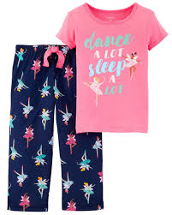
WEAR YOU FAVORITE PJS TO CLASS!!

“TWIN OR TRIPLETT TUESDAY”

HAVE FUN AND BE CREATIVE DRESSING UP LIKE YOUR FRIENDS!!

“WILD WEDNESDAY”

GO TO THE WILD SIDE AND DRESS LIKE YOUR FAVORITE ANIMAL!!

“THROWBACK THURSDAY”

DECADE DANCE DAY!! SHOW US WHAT YOUR FAVORITE DECADE IS!!

“SILLY SATURDAY”

HOW CRAZY CAN YOU GET? DRESS IN THE SILLIEST OUTFIT YOU CAN THINK OF!!

