

DO YOU LOVE TO DANCE?

Join DEDC’s Award Winning

Competitive Company!

Friday May 31st, 2019

6:00 – 7:00 Mini (ages 4-6)

6:00 – 7:30 Petite (ages 7-8)

6:00 – 8:00 Junior (ages 9-12)

6:00 - 8:00 Teen/Senior (ages 13 & up)

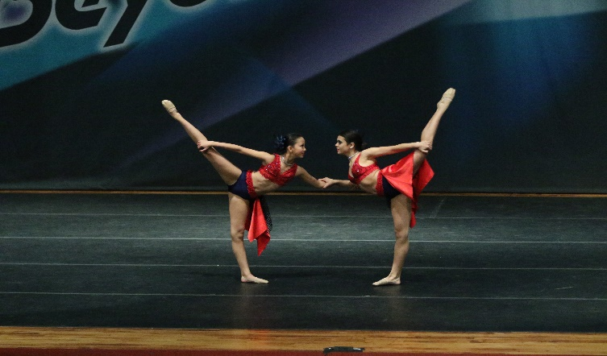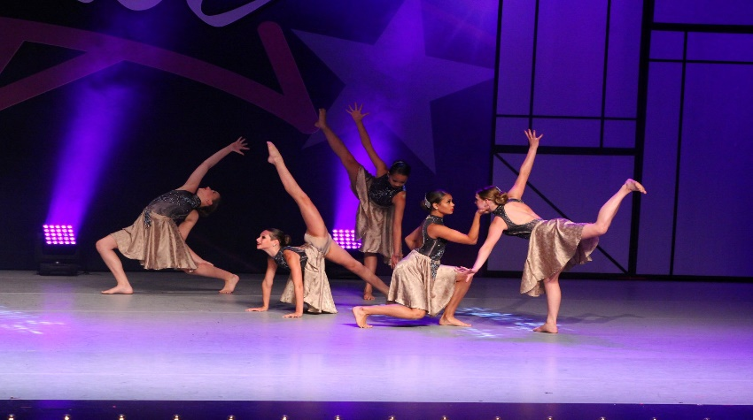

We invite you to attend our parent information meeting May 11th 11:00pm as we share all the new and exciting things in store for our

2019-2020 season!

