SUMMER SAMPLER
JULY 19th – 29th 2021
Dancers will have the opportunity to study different styles of dance each day. Dancers will learn ballet, jazz, tap, hip hop, lyrical, acro, musical theater and contemporary. Dancers will learn some basic technique for each style and a short combination. If you have ever wanted to try out new styles the sampler camp is for you! Classes can be taken in person or zoom.
Monday - Week 1
5:30-6:30 Ballet Ages 5-8
6:30-7:30 Ballet Ages 9-12

Monday- Week 2

5:30-6:30 Contemporary Ages 5-8
6:30-7:30 Contemporary Ages 9-12

Fees:
1 Week - $85 (can choose week)
2 Weeks - $150

Limited Class sizes to maintain social distancing. SIGN UP TODAY TO ENSURE SPOT!
Lobby CLOSED due to Covid – 19 Policies.
Minimum of 6 dancers signed up for each week and age bracket.

Dynamicedgedancecenter.com
dynamicedgedance@sbcglobal.net

Tuesday - Week 1
5:30-6:30 Jazz Ages 5-8
6:30-7:30 Jazz Ages 9-12

Tuesday - Week 2

5:30-6:30 Acro Ages 5-8
6:30-7:30 Acro Ages 9-12

Wednesday - Week 1
5:30-6:30 Tap Ages 5-8
6:30-7:30 Tap Ages 9-12

Wednesday - Week 2

5:30-6:30 Musical Theater Ages 5-8
6:30-7:30 Musical Theater Ages 9-12

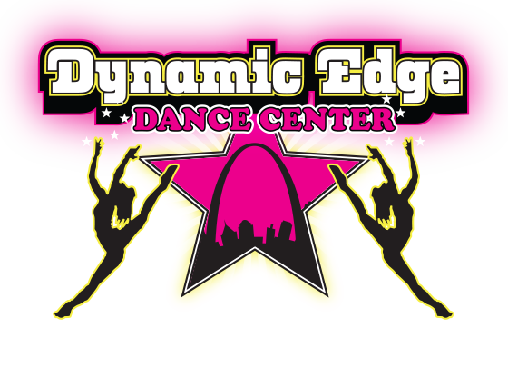

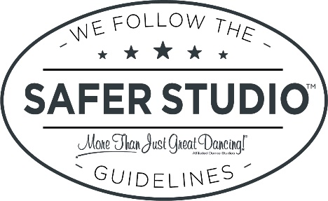

Thursday - Week 1
5:30-6:30 Lyrical Ages 5-8
6:30-7:30 Lyrical Ages 9-12

Thursday- Week 2

5:30-6:30 Hip Hop Ages 5-8
6:30-7:30 Hip Hop Ages 9-12

