Dynamic Edge Dance Center
Summer Camps 2021
Monday July 12th 9:30-12:00pm Join DEDC, Elsa, Anna and Olaf in a magical day of the unknown! Snowball fights, “ice-skating,” and dancing with our frozen friends! Register for “Into The Unknow”
Tuesday July 13th 9:30-12:00pm Allow your dancer to experience what it is like to leap and soar through the air like a ballerina. You will take the stage as a principal dancer and walk the red carpet on your way to the performance! Register for “Leap”
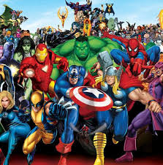 Wednesday July 14th 9:30-12:00pm Come join us in bringing out your inner Superhero! You never no what you may encounter! Obstacle courses, strength tests, and maybe even explore your secret powers! Register for “Superheros”
Thursday July 15th 9:30-12:00pm How far will DEDC go to bring adventure, hula dancing and more! Come join us to find out as we dance, set sail and so much more! Your welcome! “Register for “How Far I’ll Go”

*DEDC Mini Summer Camps will provide your dancer with a snack, craft and so much dancing of course!

Mini Summer Camp Tuition:
One Camp= $50.00 per dancer
Two Camps= $95.00 per dancer
Three Camps= $135.00 per dancer
Fourth Camp=$170.00 per dancer

