

Looking for a UNIQUE gift for your child or family member this holiday season?

Dynamic Edge Dance Center has the perfect thing! Give the gift of a 6 week mini session! We have 5 different mini sessions starting in January.

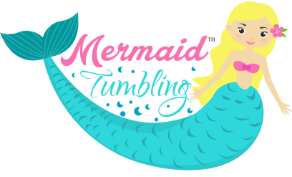
Magical Mermaid Tumbling- Ages 4 and up. There is no perquisite for this class. Students will learn fun dance and acro moves using a mermaid tail. The mini session is $85.00 and includes 6 classes and a keepsake mermaid tail you wear to class. This will be offered Tuesdays from 5:30-6:00pm (January 22nd, 29th, February 5th, 12th, 19th, and 26th).

Mystical Mermaid Tumbling- Ages 8 and up. Backbend from standing is a prerequisite for this class. Students will learn more advanced acro skills using a mermaid tail. The mini session is $85.00 and includes 6 classes and a keepsake mermaid tail you wear to class. This will be offered Saturdays from 10:00-10:30am (January 19th, 26th, February 2nd , 9th, 16th, and 23rd).
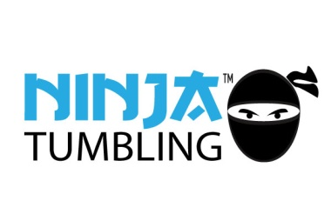
Ninja Tumbling/Training- Ages 5 and up. Did you ever want to be a ninja? Come learn cool ninja tricks and complete ninja obstacle courses. The mini session is $85.00 and includes 6 classes and a keepsake ninja t-shirt and facemask. This course will be offered Mondays from 8:00-8:30pm (January 21st, 28th, February 4th, 11th, 18th, 25th).
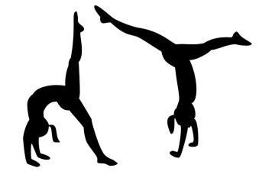
Back handspring/Aerial- Ages 5 and Up. Learn drills to help you with your back handspring or aerial. Polish up your skills if you already have them. This session is $65.00 and will be offered Saturday from 1:30-2:00pm (January 19th, 26th, February 2nd , 9th, 16th, and 23rd).
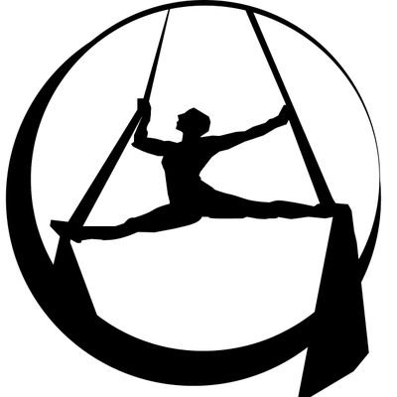
Aerial Silks Session- Age 10 and up. Must be at the acro 3 or 4 level, or have had gymnastics or tumbling training. Learn acrobatic skills and tricks while hanging from a silk fabric. Space for this class is very limited. This session is $65.00 and will be offered on Thursdays from 8:30-9:00 (January 24th, 31st, February 7th, 14th, 21st, 28th).

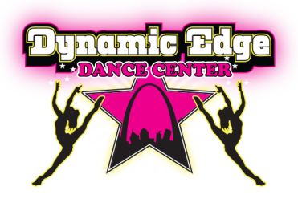
So reserve your spot today, space in limited. Lase call us at 636-305-9898 or email us at dynamicedgedance@sbcglobal.net to purchase your mini session!
